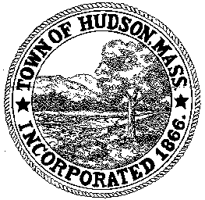

BOARD OF HEALTH
78 Main Street
Hudson, MA 01749
(978) 562-2020
Meeting Agenda
June 26, 2012
7:00 PM

- Preliminaries
1.1 Open Meeting
1.2 Roll Call

2.0 General Business
2.1 Septic Plan – 3 Parmenter Road

2.2 Silva’s Bakery

2.3 Community Garden Sponsorship

2.4 Tobacco Control Update

2.5 Substance Abuse Grant Update

2.6 NACCHO Conference

3.0 Voucher BOH 061812 - $1100
Voucher BOH 062612 – $1070
Payroll

4.0 Minutes – May 29, 2012

5.0 Correspondence
5.1 MA PHIT

5.2 Request for Review and Comments – 81 High Street

6.0 Adjournment

Next Meeting July 10, 2012

